Cost Monitoring and Control Policy
Cost monitoring and control are essential aspects of POA’s financial management. These processes help ensure that grant funds are used efficiently, effectively, and in compliance with award requirements. Cost monitoring involves regularly tracking and analyzing expenses to assess whether they align with the approved award budget and program objective. Cost control also involves identifying errors, taking corrective actions, and implementing strategies to manage costs within the approved budget. Here are the key components of cost monitoring and control:
POA Financial Reporting Process
Effective financial reporting process is a critical part of POA’s cost monitoring and control procedure. An important part of the financial reporting process is tracking and recording expenditures, performing compliance checks, and delivering clear and accurate reports that compares actual expenditures with budget.
Below are the main sources of expenditure.
- FO and Subrecipient financial reports
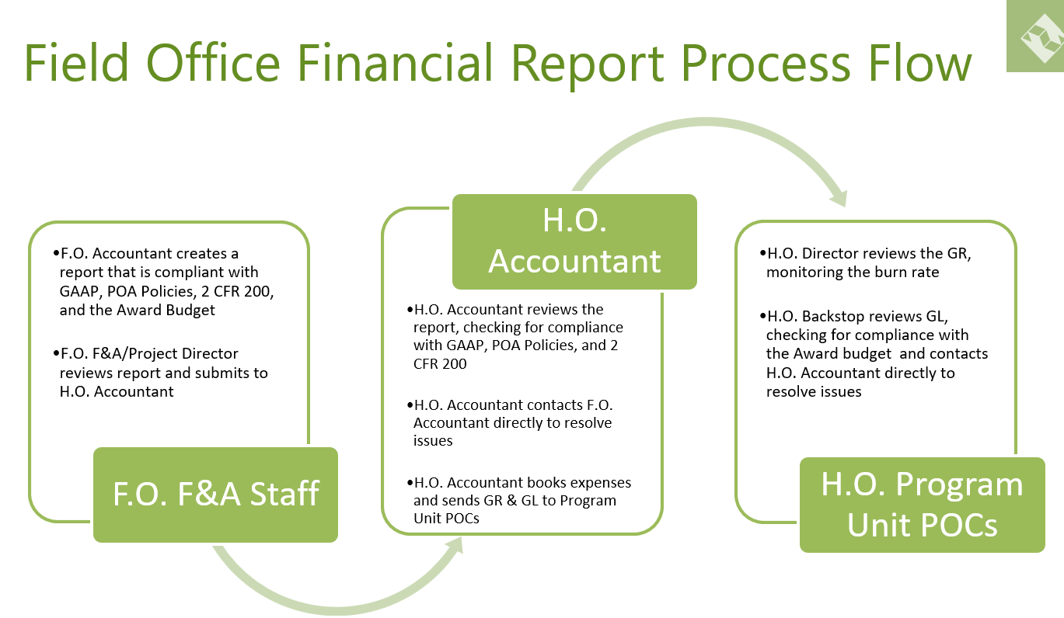

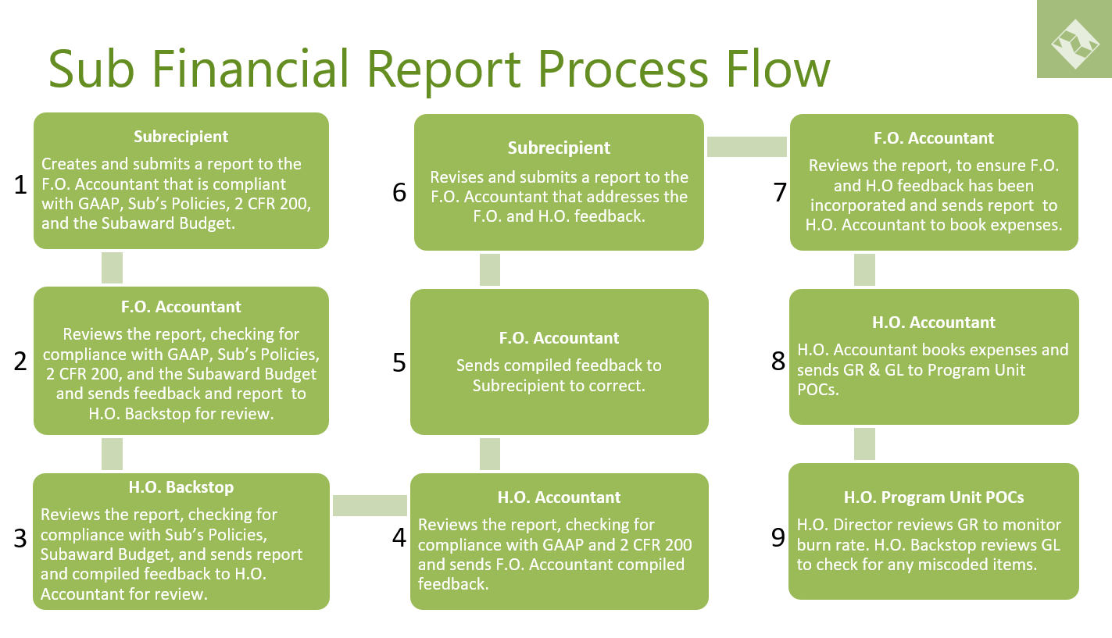

- AP Platform – BILL
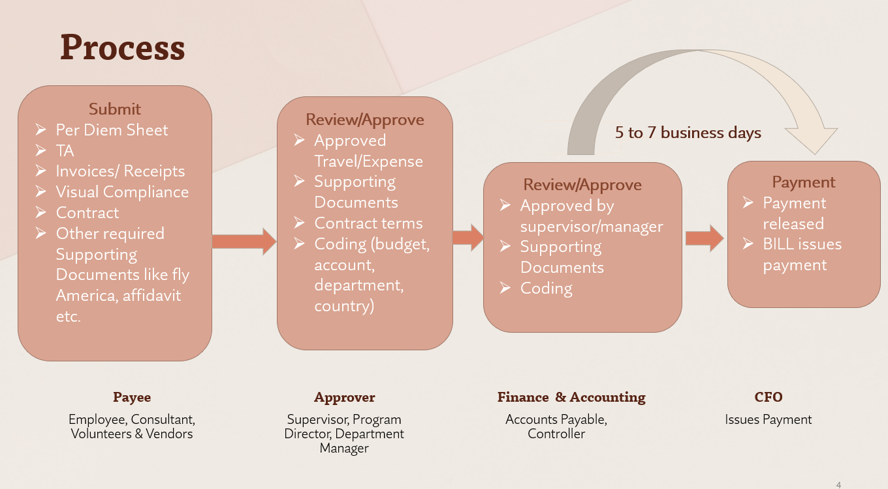
- Credit Card Expense Platform – DIVVY
Each credit card holder attaches receipts and other supporting documentation and codes each charge on their credit card. This is then approved by their supervisor.
- Other journal entries
These are transactions outside the above-mentioned sources. It includes but not limited to recording of drawdowns, bank fees, payroll, depreciation, revenue recognition and indirect cost allocation.
HO F&A reviews and records all POA’s financial transactions in Sage Intact and issues monthly grant reports and financial reports on organizational level. Program teams have full access to Sage to review their respective grant reports.
Federal Financial Reports (SF425)
HO F&A prepares and submits federal financial reports on PMS and other platforms according to each award agreement reporting frequency.
Capacity Building & Feedback Process/ FO & Subrecipient Financial Reports
- Each month, HO F&A documents compliance findings from FO expense report review process and emails a report to FO F&A director, Accountant, Program Director, Program officer and Compliance Director. Provides training as needed.
- Compliance director periodically performs spot checks to ensure FO reports are compliant with GAAP, POA/Sub Policies, 2CFR200 and award budget, award budget narrative and award provisions.
Monitoring Grant Expenditures:
Responsible: Program Director/Program Office
- Review and monitor monthly grant-related expenditures on a regular basis.
- Ensure that costs are charged to the appropriate grant budget and account codes.
- Determine if reclassification of cost is needed.
- Verify the accuracy and completeness of financial transactions related to the project.
Grant Report Analysis /Budget vs. Actual:
- Regularly compare actual expenses to the approved project budget.
- Identify any significant variances and investigate the reasons behind them.
- Analyze the impact of deviations from the budget on the project's overall financial performance.
- Determine if budget modifications are needed.
The responsibility of the Program Director entails receiving and thoroughly evaluating the monthly grant report from F&A. It is essential for the Program Director to acknowledge the receipt of the grant report and confirm the completion of their review process.
Below are key aspects of the grant report review process.
- Evaluate budget Vs Actual for each budget line.
- Verify budget categories are under the 10% budget flexibility test.
- Calculate the burn rate and adjust forecast as needed, both for life of program and POA’s FY projection.
- Submit reclassification request for errors and or expenses without budget.

Reclassification Procedure:
Reclassification requests are originated by the program team and must contain the following information.
- Complete description of expenses to be reclassified (Activity code, Funder, GL code, amount, and transaction reference number)
- If reclassification is related to payroll, the request must specify related timesheet.
- Complete description of new program/funder, activity code, GL code.
- Justification for the reclassification. Funding shortage/overage cannot be part of justification.
- Signature of appropriate program manager of all programs affected by the reclassification.
- Reclassification request must be completed in PandaDoc.
Cost Adjustment Procedures:
When necessary, adjustments to project budgets based on changes in scope, unforeseen circumstances, or external factors may lead to budget modifications. Program director must obtain necessary approvals for budget modifications from the grantor before making any changes in the financial reporting system.
Cash Flow Management:
Program directors must
- Monitor the flow of grant funds to ensure that expenditures are adequately funded.
- Implement cash flow projections to anticipate any shortfalls or surpluses in funding.
Refer to POA’s Request for Funding Policy

Program Performance Report
A program performance report is a document that provides a comprehensive overview of the effectiveness and outcomes of a particular program. This report includes detailed information on the program's objectives, activities, achievements, challenges, and impact. It serves as a valuable tool for program managers and funders to assess the success and efficiency of the program. The content and structure of a program performance report is based on the nature of the program and the reporting requirements of the award. Refer to POA’s Employee Handbook.

